Title or Task: | Title  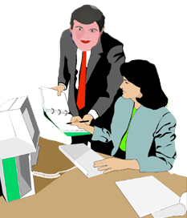

Description:

Files Required
Suitable for Classes: | All classes
Area: | Technology & Enterprise
Teacher: | Mr Peter Faulks

Timeline

Date Due:

Task Brief:

Outcomes:

Items highlighted in yellow are tasks for you to complete
Items in Blue italics are help tips



Worksheet
Graphics on Web Browser
Graphic "safe area" dimensions for layouts designed to print well:
Maximum width = 560 pixels
Maximum height = 410 pixels (visible without scrolling)
Graphic "safe area" dimensions for layouts designed for 800 x 600 screens:
Maximum width = 760 pixels
Maximum height = 410 pixels (visible without scrolling)
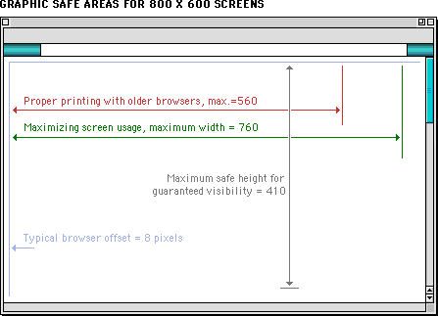

Digital image basics
Images are objects that communicate meaning or information. If an image is to be used on a computer, it must be in a digital form.
Images used on computers can be classed as either natural or artificial. A photograph is an example of a natural image. Once the photograph has been digitized (converted into numbers) a computer can store, process and manipulate the image.
Artificial images are those that have been created entirely on a computer using computer processes. There are many programs available for creating artificial digital images and graphics.
Computers have two formats for displaying and processing digital images. These two formats are vector and raster.

Vector images
Vector images are created on a computer using mathematical calculations. Vector images are used for simple geometric shapes like lines and arcs. These shapes can be combined to make squares and circles.

Raster images
Rasters, also called bitmap, are created on a computer using pixels. Pixels are arranged in grids where their combined colours and tones produce the image. Raster is best used for complex or photographic images.

Computer graphics
Computer graphics can be described as images that are pictorial. Pictorial means they look like a picture but are not a photograph. Graphics are most commonly thought of as drawings as they are a combination of lines and arcs. Drawing programs like Corel DRAW®, Microsoft® Paint and Adobe® Illustrator® store graphics files as vector images.
Photographs are very complex images composed of many different colours and tones. Photographs are stored and manipulated on a computer as raster images. Photo-editing programs such as Paint Shop Pro®, Adobe® Photoshop® and Macromedia® Fireworks® work by altering the colour or position of individual pixels. Some programs such as Corel DRAW® can process both raster and vector images.

Clip Art
Clip art is the name given to a collection of graphical images designed to be copied and inserted into other applications, such as a word processor. Clip art was made popular when it was included in many Microsoft® products. Clip art is now widely available on the Internet.

Icons
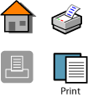
Icons are special graphics designed to represent a particular action or meaning. Icons are used because they resemble a function or an object that performs a function. Examples of icons include the image of a house to represent returning home; a picture of binoculars to represent searching; or a magnifying glass that informs a user that it is possible to zoom in or out on an object. Like Clip art, icon libraries are now available on the Internet and compact disc libraries.

Different save formats

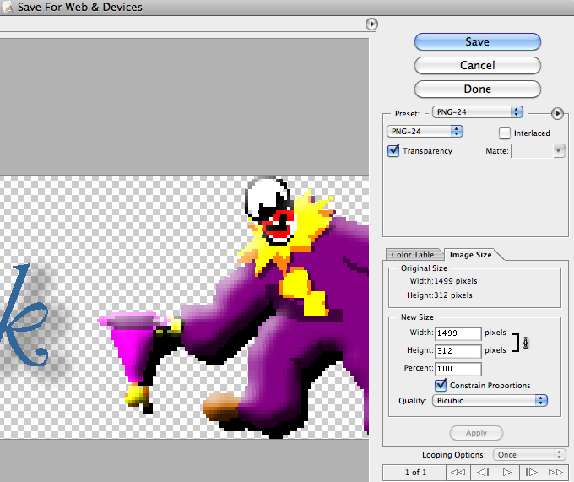

PNG Transparent background (PNG-24 is better)

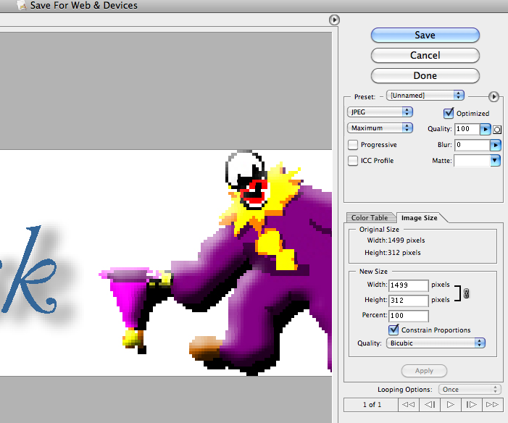

Jpeg Good for Web and photos

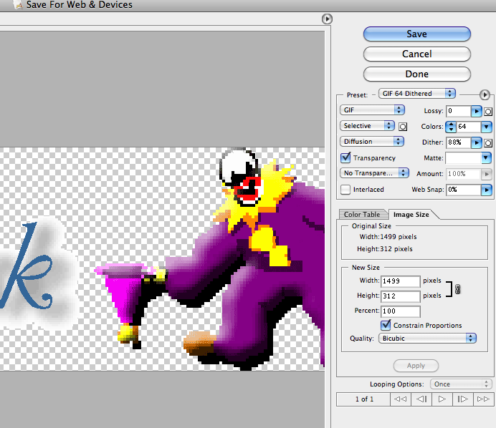

Gif can be used for animation

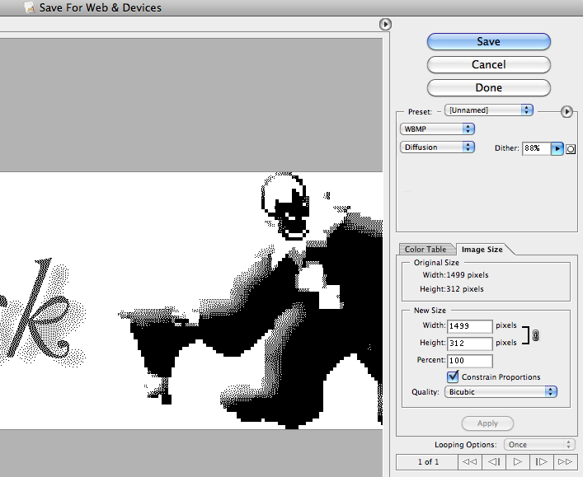

Wbmp loss of colour and at different settings
Pattern
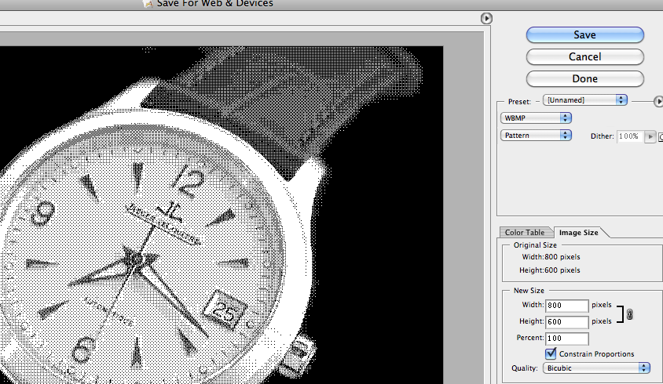
Noise
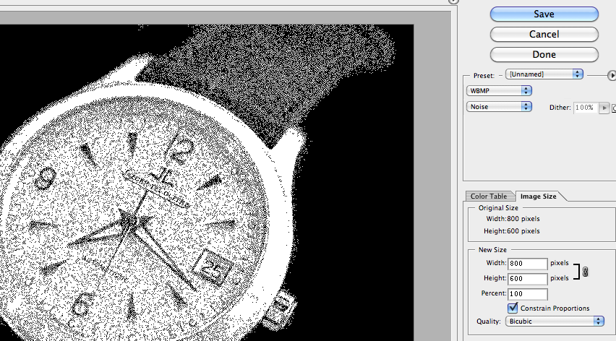
Diffuse
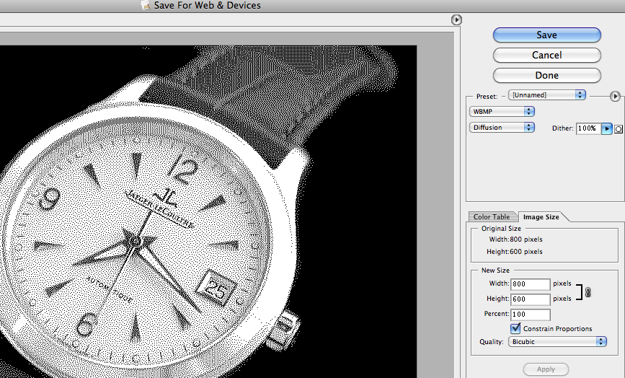

Understanding images
There are several file types used to store images. Most of these file types compress the image; The more often you edit and save, the more degraded the image will be.
Photographs are best saved as JPEG images. To gain a fuller understanding of manipulating images try the following:
Select a digital photograph and try saving the image at different levels of compression.
300dpi and one at 150dpi and 72 dpi
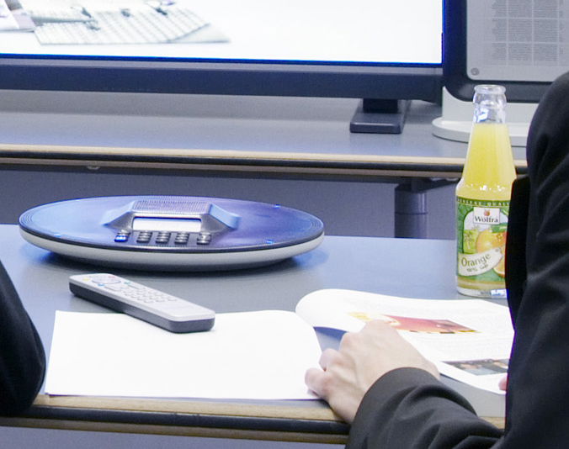 jpeg
You might like to discuss your answers with your teacher or compare results with fellow students.
Your aim is to get the best balance between file size and image quality. Compare the file sizes and qualities of each saved image and then answer the following questions.
- At what point in compression does the JPEG become too poor to use on a web page? Is that point the same for all the photos you experimented with?
- How do the GIF and JPEG files compare in quality and file size? What conclusions can you draw?
- Create a graph comparing the JPEG file sizes against the different compression levels. Describe the trends. What conclusions can you draw?
- Create a table comparing and contrasting the following graphic file formats: BMP, GIF, JPEG and PNG. In your table include information on uses, colour, compression, size, lossy, advantages and disadvantages.
Use the internet and reference books to find all the information. The following web sites have some useful information on images.
  - www.wotsit.org .
  - http://graphicsoft.about.com
You need to include some graphics in an electronic presentation on the World Wide Web. The software program you are using only allows the graphic file formats: JPEG, GIF and PNG. The following two graphics of the same resolution are very different. Suggest the most appropriate format to use for each graphic, and provide reasons for your choice.
Graphic 1 is Full colour photograph | Graphic 2 is a black and white line diagram
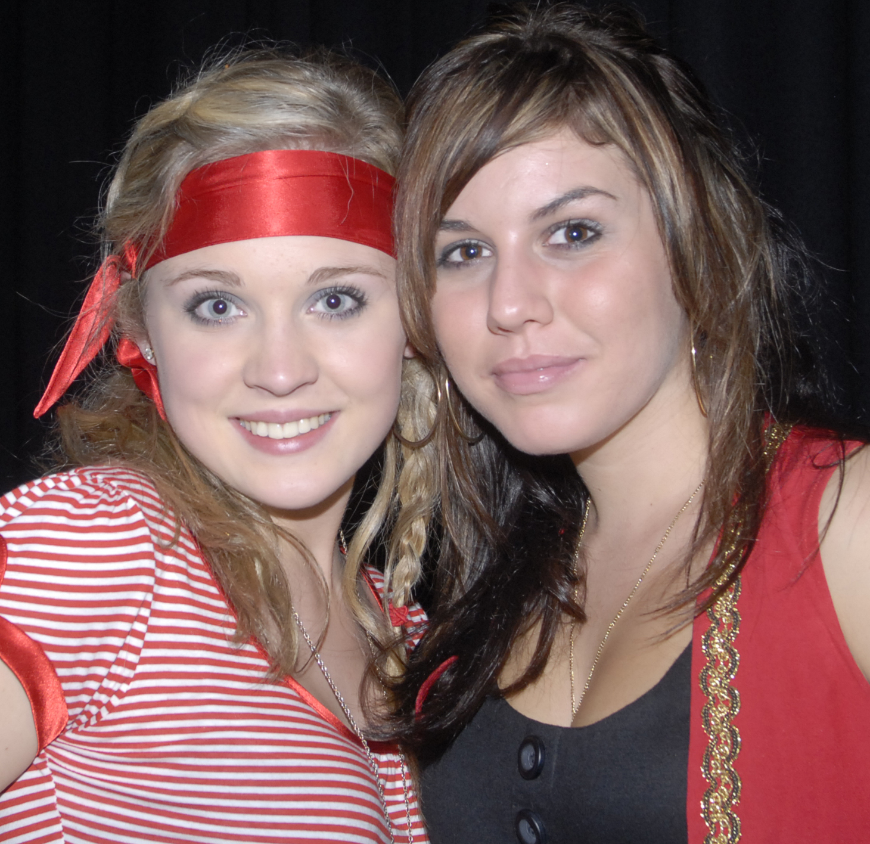 | 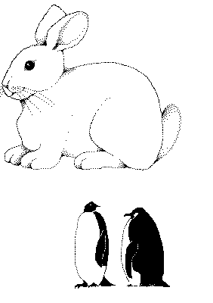
Given the list below which would you choose for Graphic 1, and 2?
- Graphic 1
  - Which Format would you choose
  - Reasons
- Graphic 2
  - Which Format would you choose
  - Reasons

PPI Pixels per inch is a measurement of the pixel density (resolution) of an electronic image

PPCM pixels per centimeter is a measurement of the pixel density (resolution) of an electronic image

Dpi - dots per inch dots per inch in a digital print and the printing resolution of a hard copy print

Various Types of image formats
File Format | BMP  Bitmap | GIF  Graphics Interchange Format | JPEG  Joint Photographic Experts Group | PNG  Portable Network Graphics
Uses | Pattern of pixels or tiny coloured dots. | Web graphics. Ideal for graphics that use only a few colours. Used for bitmap images – line drawings or blocks of a few distinct colours. | Web graphics. Photographs & scanned photos. Images with few distinct colours – illustrations, cartoons, icons & images with blocks of colour. | Web graphics. Single images only.
Colour | Fixed colour palette. | Maximum 256 colour. | True colour 24 bit graphics. Capable of displaying 16.7million colours. | True colour palette and grey scale. 16 million colours.
Compression | Not supported. | Highly compressed – no loss of data. | Smaller than GIF, less compression but better image quality. | 10 – 20% more than a GIF. No loss of data.
Size | Very large. |  | Highest quality – largest file.  Smaller files – reduced quality.
Lossy | No. | Yes – no image quality lost. | Yes. | No.
Advantage | Good for small picture graphics & basic logos. | Can be transparent. Maintains resolution and sharpness even when compresses. Supports animation. | Compresses colour better and retains a high degree of colour fidelity. Can look almost as good as a photo. | Will eventually replace GIF. Platform independent. Greater colour support and better compression. Better support for transparency.
Disadvantage | Large file size. | Loses quality with high resolution pictures. Not effective for detailed photographs. | Not good with straight lines. Smaller file size the more picture info is lost & further away from original. Does not support transparency. | Doesn’t support animation. New format, so only recent browsers can display PNG graphics.

Detailed explanation follows…

Common Raster Image Formats

Windows Bitmap (.bmp)
A common image format in Windows programs. Good for printing images
Advantages Disadvantages
• No loss in quality
• Millions of colours
• Preferred format in some Windows applications
• Large File Size
• Only used in Windows and may not be recognised in other systems

Tagged Image File Format (.tif)
An image format recognized by most computer systems. Useful if compatibility with non-windows systems is an issue. Used as the preferred image format by many professional printers due to its high quality.
Advantages Disadvantages
• No loss in quality
• Millions of colours
• Not specific to Windows – used on other operating systems such as Mac and Linux
• Large File Size
• Not compatible with some windows applications
• More options than BMP

Joint Photographic Experts Group – JPEG (.jpg .jpeg .jpe)
A common image format for use on the Internet and in digital cameras due to its small
file size. It uses complicated compression algorithms to reduce the size of files while sacrificing a small amount of image quality. Information discarded is often not visible to the human eye. When a picture is saved as a JPEG file, most editing programs allow you to choose the compression ratio. More compression means a smaller file but poorer image quality.
Advantages Disadvantages
• Millions of colours
• Recognised these days on most computers and in most applications
• Format used by many digital cameras
• Common format for pictures in websites
• Progressive image rendering
• Small file size
• Some loss in quality
• Doesn’t look as good when used in professional quality print jobs
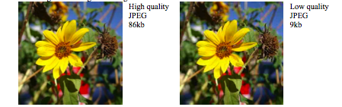
Low quality
JPEG
9kb

High quality
JPEG
86kb

Graphic Interchange Format (.gif)
The first image format to be used on the World Wide Web. Gif images are good for images with a limited number of colours, such as logos, graphs and drawings, but are not as good for photos and more complex images.
Advantages Disadvantages
• No loss in quality
• Small file size due to method of storing image information
• Progressive rendering (interlacing)
• Transparent areas
• Animation
• Limited to a maximum of 256 colours in an image so some types of images won’t look good in GIF format
• Uses a patented technology for compression, so any program using it must pay a license fee

Portable Network Graphic (.png)
A fairly new image format which was created to be a licence free improvement on the
GIF format.
Advantages Disadvantages
• Can have 256 colours like a GIF or millions of colours like a JPEG
• Supports alpha channels allowing full and partial transparency
• Progressive rendering
• Small file size due to compression
• Files with millions of colours are often larger than similar JPEG images
• Not yet supported in some programs
• Doesn’t support animation like GIF

For good information on the differences between GIF, JPEG and PNG see
http://www.webopedia.com/DidYouKnow/Internet/2002/JPG_GIF_PNG.asp

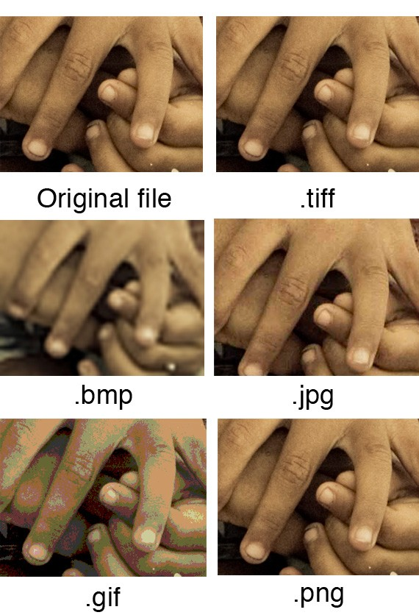

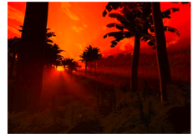

Common Raster Image Editing Programs
Adobe Photoshop
Macromedia Fireworks
Corel Paint
Jasc Paintshop Pro
GIMP


Need help just ask

